April | SMC FRANCE TRIP 2014: 3.4. - 28.4.2016
2016 | 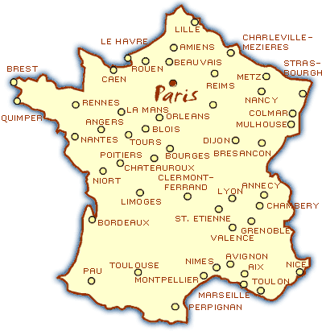

Monday | Tuesday | Wednesday | Thursday | Friday | Saturday | Sunday
 |  |  |  | 1 | 2 | 3
Departure
Christchurch
4 | 5 | 6 | 7 | 8 | 9 | 10
Paris/  Toulouse | Toulouse  school | Toulouse  school | Toulouse  school | Toulouse  Carcassonne or Albi | Toulouse  families | Avignon
11 | 12 | 13 | 14 | 15 | 16 | 17
Avignon  Palais des Papes | Avignon  Nîmes Arènes Maison Carré  Tour Magne | Avignon  Pont du Gard  Uzès | Avignon  Orange Amphithéâtre | Amiens  Cathedral | Amiens  Marché  Musée Albert  Thiepval/  Longueval | Amiens  Arras tunnels NZ memorial
18 | 19 | 20 | 21 | 22 | 23 | 24
Evreux  families | Evreux  families/school  language day | Paris  Notre Dame  Tour Eiffel | Paris  in groups | Paris  in groups | Paris  Versailles | Paris  in groups
25 | 26 | 27 | 28 | 29 | 30 | 31
Paris  marché Bastille  Bateau mouche | Departure  Paris | Singapore  Stop Over | Arrival Christchurch
Term 2 Start

Toulouse: 6 nights in families, individual activities and group activities. School visit. Day trip. | Avignon: 5 nights in a hostel. Day trips to Nîmes, Pont du Gard, Uzès, Orange. | Amiens: 3 night in hostel, city tour, group activities. WWI museum Albert, cemetery, baking class, cooking | Evreux: 2 nights in families. Group activities related to the Shared Histories project. School visit. | Paris: 6 nights in a Youth Hostel. Activities in small groups, day trip to Versailles. | Singapore. Activities depending on flight schedule: Swimming pool, city tour or beach

